Tool 3: Mini risk assessment

This template provides a step by step guide on how to run a short, half-day workshop to undertake a risk and opportunity mini assessment. It also includes a template to help you structure and document discussions, to serve as the basis for decided whether a more in-depth risk assessment is needed. The results can also be used in future adaptation planning efforts both for the project and the wider organisation.

Step 1: Selecting relevant climate hazards for the discussion
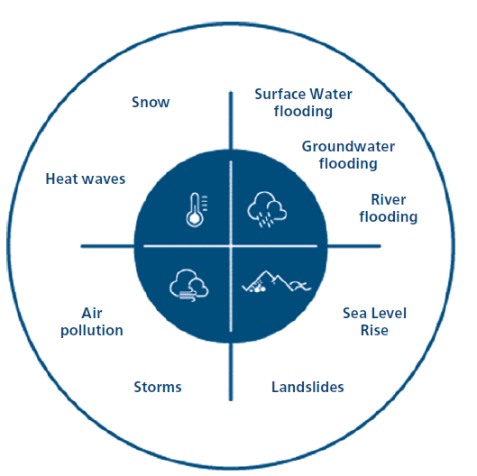
In the project group, use the weather event diagram below to select 2-3 climate risks that may impact your project. The choice can be based on weather events that have hit the project area or wider region in the past or the events that would affect your project or site the most, if it were to happen. If there are no recent examples, one other approach would be to explore the impact that potential climate hazards that would affect your project or site in a significant way if it were to occur. If you organisation has already begun to work on adaptation, it may be worth bringing in this work to inform the discussion.
The weather event diagram above shows nine common weather events and climate hazards that could affect projects across Scotland.
Alternatively, you could select two or three from the more comprehensive list below, depending on whether your project is sensitive. Try to find the most relevant hazards to discuss in the group depending on the type of project you are delivering and the location of your site.
Air temperature increase | Extreme temperature /Heatwaves | Change in incremental/extreme rainfall
Changes in extreme rainfall | Average /maximum wind speeds | Humidity
Solar radiation | Relative sea level rise | Seawater Temperature
Water availability | Storms | Flooding (coastal and fluvial)
Ocean PH | Dust Storms | Coastal erosion
Soil erosion | Soil salinity | Air Quality
Ground instability/landslides | Urban Heat Island | Growing season

Step 2 – Explore climate risk to your project, to your site and to your surroundings
Having selected your hazards, use the following template to consider how they could affect your site and assets and project activities, as well as the effect that constructing your project will have on how those hazards are experienced. Document your answers in the spaces below.
Area | Internal Focus | External Focus
Site and assets | How will the site and assets of my project be affected by the chosen extreme weather events? | How will the projects’ surrounding environment be affected by the chosen weather events (consider secondary impacts access to your site or overflow surface water if a neighbouring site is hit)?
Project activities | How will the key activities of my project be affected by the chosen weather events? | How will the weather events affect external activities that are important to my project performance (e.g. inputs necessary for your project to function or transport links connecting your project to the market)?
Impacts of the project on surrounding areas | Will the construction of the project make the project site more or less at risk to the chosen extreme weather events? | Will the construction of the project make the surrounding sites more or less vulnerable to the weather events? (For example, building on a green space could make the surroundings more likely to become urban heat islands and more prone to flooding)

Step 3 - Listing most important risks and how they are being addressed
After a summary discussion of the potential effects of the hazards, organise your discussions into a short, high level risk register. Document the most important risks and the consequences that could happen if it were to occur. When considering which risks are most important, consider things like the impacts on finance, reputation, or the ability to deliver core functions.
Then, spend a little thinking about the likelihood of those risks occurring and the impact on your organisation if they were to occur and document them.
RISK | CONSEQUENCE | LIKELIHOOD | IMPACT
What is the risk – i.e. the risk to a certain asset or function from a hazard. E.g.  Risk of damage to buildings from flooding | Describe / list the key things that coud happen as a result  E.g.  Reduced access  Cost of repair  Loss of productivity | (H/M/L) | (H/M/L)

Step 4 – Assessing stakeholders, actions and effects
After a summary discussion of the potential effects of the hazards, take some time to discuss the extent to which you’re able to manage the hazards, what action you can take and the consequences of these. This should also include a consideration of the relationships with other stakeholders who may be able to help realise your aspirations, or could be adversely affected.
 | INTERNAL | EXTERNAL
Agency and dependencies on others | What climate-related risks are we able to manage within the scope of my project? | What risks are the responsibility of other stakeholders? Who are they? How will they affect our project?
Actions | What action can we take within my project to mitigate risks (this can be both built responses but also no/low regret measures such as maintenance, contingency plans and insurance)? | What action can we encourage external stakeholders to take to mitigate risks to your project/site? How can we ensure they are taken?
Effects of adaptation measures | Does our climate adaptation solution solve the problem or transfer the problem to another site? | Will a future off-site adaptation solution transfer a problem to our site?

Afterwards, discuss whether or not the group feels the risks are adequately addressed already in the project. If they are not, discuss the best way to develop an appropriate response. This could involve
- undertaking a more substantial risk screening or, risk assessment in house using the other tools in this toolkit,
- commissioning a consultant-led Climate Risk and Vulnerability Assessment,
- developing a short adaptation plan to address the issues above, or
- building in adaptation requirements in your design brief.

